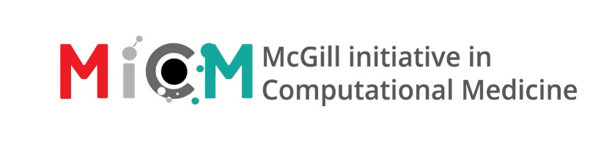
How to think in code
Date and Time: February 2nd, 2026
Location: 550 Sherbrooke, room 189

Workshop Lead: Maria Haddad
Facilitator: N/A
Registration link: Form
Approximate duration: 2 hours

Prerequisites:
- Basic mathematical knowledge (number properties, algebra, equations)
- A computer with the ability to access the internet, running a current version of Windows, Mac OS X, or Linux.
- Create a free account on https://brilliant.org for the hands-on parts

Summary: (2-3 sentences summarizing the workshop)
This workshop will introduce the world of programming to complete beginners. The goal of this workshop is to act as an introduction to people who have never taken a coding class, have zero to minimal experience writing code, and who are interested in learning!
Learning Outcomes:
- Brief introduction to the hardware of a computer: how a computer works – explaining components such as RAM, CPU, and GPU, and how programs connect you to the computer.
- Basics of a program: Students will learn what a program is, how to write pseudocode, and what an algorithm is.
- Understanding loops: Students will get hands on experience creating loops with Brilliant.com using pseudo-code blocks.
- Coding fundamentals: Students will learn the basics of variables, Boolean logic, conditional statements, and data structures. Given time, we will dip our toes into Python using https://codehs.com/ide which has an online IDE.
Content
- Module 1: Overview of Computers and Programs (30 minutes)
  - What is a computer?
    - What is a CPU?
    - What is RAM?
    - Why does a program need both?
  - What is a computer program?
  - Basics of a program
    - Sequence of instructions
    - Pseudo-code
    - Algorithms
    - First 6 modules of Brilliant.org’s 1.1 Thinking in Code
- Module 2: Coding fundamentals and Hands-on testing (30 mins)
  - Basic Variables
  - Data Types
    - Strings
    - Integers
  - Boolean Logic
    - AND, OR, NOT, and more
  - Conditionals
  - Loops
    - For
    - While
- Break (5 minutes) – if necessary
- Module 3: Functions and Data Structures (45 minutes)
  - Functions
  - Data Structures
    - Lists
    - Arrays, Vectors, and Dataframes
    - Indexing
- Conclusion and Q&A (10 minutes)
  - Recap of the workshop
  - Open discussion and Q&A
  - Guidance on further learning resources

